**Chapter 1**

* 1. **About Department of Atomic Energy**
  2. **How nuclear reactor generates electricity**
  3. **India’s three stage nuclear power programme**
  4. **About Nuclear Fuel Complex (NFC)**
  5. **Material flow process in NFC**

**ABOUT DEPARTMENT OF ATOMIC ENERGY (DAE)**

The Department of Atomic Energy (DAE) was set-up on August 3, 1954 under the direct charge of the Prime Minister. The vision of the DAE is to empower India through technology, creation of more wealth and providing better quality of life to its citizen. This is to be achieved by making India energy independent, contributing to provision of sufficient, safe and nutritious food and better health care to our people through development and deployment of nuclear and radiation technologies and their applications.

DAE is engaged in the design, construction and operation of nuclear power/research reactors and the supporting nuclear fuel cycle technologies covering exploration, mining and processing of nuclear minerals, production of heavy water, nuclear fuel fabrication, fuel reprocessing and nuclear waste management. It is also developing advanced technologies that contribute to the national prosperity. The spin-off technologies, human resource developed and technical services being rendered by the Department have been greatly helping the Indian industry. It is also developing better crop varieties, techniques for control/eradication of insects thus protecting the crops, radiation based post harvest technologies, radiation based techniques for diagnosis and therapy of disease particularly cancer, technologies for safe drinking water, better environment and robust industry.

Main Focus areas of work in DAE are:

1. Increasing share of nuclear power through deployment of indigenous and other proven technologies, along with development of fast breeder reactors and thorium reactors with associated fuel cycle facilities.
2. Building and operation of research reactors for production of radioisotopes and carrying out radiation technology applications in the field of medicine, agriculture and industry.
3. Developing advanced technologies such as accelerators, lasers, supercomputers, advanced materials and instrumentation, and encouraging transfer of technology to industry.
4. Support to basic research in nuclear energy and related frontier areas of science, interaction with universities and academic institutions, support to research and development projects having a bearing in DAE’s programmes and international co-operation in related advanced areas of research and
5. Contribution to national security.

DAE has made the following significant contributions of DAE to the national initiatives:

1. **AGRICULTURE:** Enhanced production of oilseeds and pulses
2. **EDUCATION, HEALTH:**
   1. Homi Bhabha National Institute (HBNI)
   2. National Initiative on Undergraduate Science (NIUS)
   3. Countrywide Services in Cancer through Telemedicine
3. **FOOD & NUTRITION SECURITY:** Radiation Processing of Food & Agro Products.
4. **WATER RESOURCES:** Desalination in water scarcity areas along the sea coast.
5. **ENERGY SECURITY:** Electricity supply in near and long term ensuring long term sustainable development.

DAE has been constantly striving for the development of the nation by its miscellaneous researches in the field of radiation. This prolific institution has always supported the country as a part of its backbone and gave its mechanical balance to the country’s growth.

There are still many researches going on under this mammoth organisation for the development of many areas like medical research, power generation, agriculture, military, etc., such kind of researches have been taken up by this organisation for making the country whose needs are self sufficient.

DAE hopes that such kind of beneficial researches shall always be taken up for the betterment of the country and prove our country to be the best among all other countries in the world by making to reach the country towards a pinnacle mark of success and prosperity.

Departments under DAE:-

* [Tata Institute of Fundamental Research](http://www.tifr.res.in/)
* Bhabha Atomic Research Centre
* [Saha Institute of Nuclear Physics](http://www.saha.ac.in/)
* [Tata Memorial Centre](http://tmc.gov.in)
* [Harish-Chandra Research Institute](http://www.hri.res.in/)
* [Institute of Physics](http://www.iopb.res.in/)
* [National Institute of Science Education and Research](http://www.niser.ac.in/)
* [Institute of Mathematical Sciences](http://www.imsc.res.in/)
* [Institute for Plasma Research](http://www.ipr.res.in/)
* [Board of Research in Nuclear Sciences (BRNS)](http://www.barc.gov.in/brns/index.html)
* [National Board for Higher Mathematics (NBHM)](http://www.nbhm.dae.gov.in/)
* [Atomic Energy Education Society](http://www.aees.gov.in/)
* [Homi Bhabha National Institute](http://www.hbni.ac.in/)
* [Nuclear Power Corporation of India Ltd](http://www.npcil.nic.in/)
* **Nuclear Fuel Complex**
* Heavy Water Board
* Board of Radiation and Isotope Technology
* Indira Gandhi Centre for Atomic Research
* Raja Ramanna Centre for Advanced Technology
* Variable Energy Cyclotron Centre
* Atomic Minerals Department
* Global Centre for Nuclear Energy Partnership
* [Bharatiya Nabhikiya Vidyut Nigam Ltd](http://www.bhavini.nic.in/)
* [Uranium Corporation of India Ltd](http://www.ucil.gov.in/)
* [Indian Rare Earths Ltd](http://www.irel.gov.in/)
* [Directorate of Construction & Estate Management](http://www.dcsem.gov.in/)
* [Directorate of Purchase and Stores](http://www.dpsdae.gov.in/)
* [General Services Organisation (GSO), Kalpakkam](http://www.igcar.ernet.in/gso/)

**HOW A NUCLEAR REACTOR GENERATES ELECTRICITY**

A nuclear reactor produces and controls the release of energy from splitting the atoms of uranium.

Uranium-fuelled nuclear power is a clean and efficient way of boiling water to make steam which drives turbine generators. Except for the reactor itself, a nuclear power station works like most coal or gas-fired power stations.

**The Reactor Core**

Several hundred fuel assemblies containing thousands of small pellets of ceramic uranium oxide fuel make up the core of a reactor.  For a reactor with an output of 1000 megawatts (MW), the core would contain about 75 tonnes of enriched uranium.

In the reactor core the U-235 isotope fissions or splits, producing a lot of heat in a continuous process called a chain reaction.  The process depends on the presence of a moderator such as water or graphite, and is fully controlled.

The moderator slows down the neutrons produced by fission of the uranium nuclei so that they go on to produce more fissions.

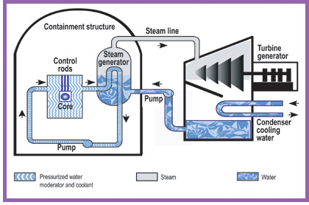Some of the U-238 in the reactor core is turned into plutonium and about half of this is also fissioned similarly, providing about one third of the reactor's energy output. The fission products remain in the ceramic fuel and undergo radioactive decay, releasing a bit more heat.  They are the main wastes from the process. The reactor core sits inside a steel pressure vessel, so that water around it remains liquid even at the operating temperature of over 320°C.  Steam is formed either above the reactor core or in separate pressure vessels, and this drives the turbine to produce electricity.  The steam is then condensed and the water recycled.

**INDIA’S THREE STAGE NUCLEAR POWER PROGRAMME**

India's three-stage nuclear power programme was formulated by Dr. [Homi Bhabha](http://en.wikipedia.org/wiki/Homi_Bhabha) in the 1950s to secure the country’s long term energy independence, through the use of [uranium](http://en.wikipedia.org/wiki/Uranium) and [thorium](http://en.wikipedia.org/wiki/Thorium) reserves found in the [monazite](http://en.wikipedia.org/wiki/Monazite) sands of coastal regions of [South India](http://en.wikipedia.org/wiki/South_India). The ultimate focus of the programme is on enabling the thorium reserves of India to be utilised in meeting the country's energy requirements. Thorium is particularly attractive for India, as it has only around 1–2% of the global [uranium reserves](http://en.wikipedia.org/wiki/List_of_countries_by_uranium_reserves), but one of the largest shares of global [thorium reserves](http://en.wikipedia.org/wiki/Thorium#American_Assessment) at about 25% of the world's known thorium reserves.

The country published about twice the number of papers on thorium as its nearest competitors, during each of the years from 2002 to 2006. The Indian nuclear establishment estimates that the country could produce 500 GWe for at least four centuries using just the country’s economically extractable thorium reserves.

As of 2012, the first stage consisting of the [pressurised heavy water reactors](http://en.wikipedia.org/wiki/Pressurised_heavy_water_reactor) (PHWR) is near completion of its planned goals, the second stage consisting of [fast breeder reactors](http://en.wikipedia.org/wiki/Breeder_reactor) (FBR) is poised to go into operation within one year, and the third stage consisting of [advanced heavy water reactors](http://en.wikipedia.org/wiki/Advanced_heavy_water_reactor) (AHWR), as one among several technology options, is slated to begin construction so that its commissioning can be done by 2020. The recent [Indo-US Nuclear Deal](http://en.wikipedia.org/wiki/U.S.-India_Civil_Nuclear_Agreement) and the [NSG](http://en.wikipedia.org/wiki/Nuclear_Suppliers_Group) waiver, which ended more than three decades of international isolation of the Indian civil nuclear programme, have created many hitherto unexplored alternatives for the success of the three-stage nuclear power programme.

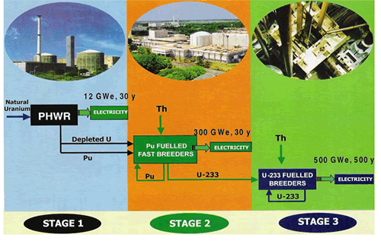

**ABOUT NUCLEAR FUEL COMPLEX (NFC)**

The ***Nuclear Fuel Complex*** (NFC) was established in 1971 as a major industrial unit of [Department of Atomic Energy](http://en.wikipedia.org/wiki/Department_of_Atomic_Energy_%28India%29), for the supply of [nuclear fuel](http://en.wikipedia.org/wiki/Nuclear_fuel) bundles and [reactor](http://en.wikipedia.org/wiki/Nuclear_reactor) core components. It is a unique facility where natural and [enriched uranium](http://en.wikipedia.org/wiki/Enriched_uranium) fuel, [zirconium](http://en.wikipedia.org/wiki/Zirconium) alloy cladding and reactor core components are manufactured under one roof. NFC symbolizes the strong emphasis on self-reliance in the Indian Nuclear Power Programme.

Zirconium ore is obtained from the beach sands of Kerala and Tamilnadu. Natural [uranium](http://en.wikipedia.org/wiki/Uranium), mined at [Jaduguda Uranium mine](http://en.wikipedia.org/wiki/Jaduguda_Uranium_Mine) in the [Singhbhum](http://en.wikipedia.org/wiki/Singhbhum) area in the state of [Jharkhand](http://en.wikipedia.org/wiki/Jharkhand), both are converted into nuclear fuel assemblies over here.

Functions and achievements of NFC include:-

* Plans to establish two major fuel fabrication facilities to meet the expected jump in nuclear power production.
* Doubled the capacity and delivered the fuel for all the new and operating reactors of NPCIL, with a sound and comprehensive quality management system, the fuel performance in the reactors has been found to be comparable to international standards with a very low fuel failure rates.
* Fabricates core sub assembles and components for the LMFBR programme including the operating fast breeder test reactor and the forthcoming prototype FBR.
* Manufactures seamless stainless steel and special alloy tubes, high purity and advanced materials for various hi – tech applications in atomic energy, defence, space and other industries, zirconium alloy components for non nuclear applications in fertilisers and heavy chemical industries.
* Implemented sound occupational health, safety and environment management system. The green environment of the premises testify the eco- friendly plant operations as a benevolent employer, NFC provides housing assistance, Medicare and educational facilities to all employees and their families.
* 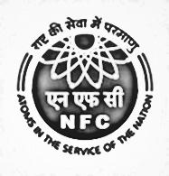Accredited with ISO 9001, ISO 14001 and OHSAS 18001 certification and strengthening corporate R&D, poised to meet the future requirements of the nuclear power programme.

**MATERIAL FLOW PROCESS IN NFC**

There are majorly two types of materials in NFC which are Zirconium and Uranium these follow typical steps of processes to obtain desired materials.

Flow of Zirconium:-

Flow of Uranium:-

**Chapter 2**

**2.1 Special Tube Plant (STP)**

**2.2 Properties of Zirconium**

**2.3 Project Statement**

**SPECIAL TUBE PLANT (STP)**

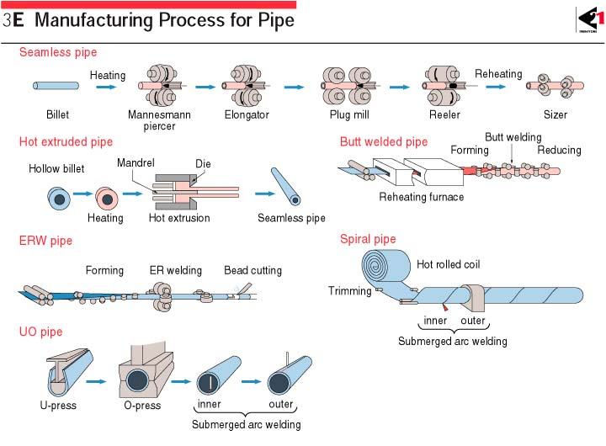Tubes can be manufactured by various processes as shown below:-

The special tube plant in NFC reprocesses the hot extruded tubes to final dimension by the process of pilgering.

There are many ways of manufacturing the tubes as shown above but, NFC uses extrusion process also known as double radial forging for the manufacturing of Zircalloy tubes which comprise calandria, coolant, fuel tubes, etc., the extruded tubes due to hot working may not come with exact dimensions and properties as required so, the tubes are further processed to achieve the exact dimensions and required properties.

The pilgering process takes place in this Special Tube Plant of NFC. Other machining processes like honing, grinding, annealing, etc., for the tube also take place in this plant itself.

**PROPERTIES OF ZIRCONIUM**

Zircalloy tubes are used in nuclear reactors as pressure tubes, calandria, fuel tubes, etc., zirconium being less absorbent to neutrons gives the advantage of smooth functioning of nuclear reactor by providing maximum fissions. Coolant tubes are made of Zr–Nb 2.5 zirconium alloy which consists of 2.5% Niobium in Zirconium with some other alloying elements. Calandria tubes are made of zircalloy 4 which consists of alloying elements like tin, iron, chromium, etc., in it. The whole structure of the fuel assembly is as shown in the figure below:-

 The calandria is the whole support for the reactor, the pressure or coolant tube fits inside the calandria housing the fuel bundles for the nuclear fission reaction. The spacers provide thermal insulation between the calandria and the pressure tubes. Generally, the pressure tubes are separated by a Garter spring system. Proper insulation is required to monitor the temperature of the core to a certain level required.

Different kinds of zirconium alloys can be used for different purposes depending on the nature of their mechanical properties. Since, different alloys have different practical uses on the nature of their alloying elements present in them similarly; the zirconium alloys also have their wide range of uses respectively.

Various other alloys of zirconium and their respective uses are as follows:-

|  |  |  |  |  |
| --- | --- | --- | --- | --- |
| **Alloy** | **Sn%** | **Nb%** | **Component** | **Reactor type** |
| Zircaloy 2 | 1.2–1.7 | – | Cladding, structural components | [BWR](http://en.wikipedia.org/wiki/Boiling_water_reactor), [CANDU](http://en.wikipedia.org/wiki/CANDU_reactor) |
| Zircaloy 4 | 1.2–1.7 | – | Cladding, structural components | [BWR](http://en.wikipedia.org/wiki/Boiling_water_reactor), [PWR](http://en.wikipedia.org/wiki/Pressurized_water_reactor), [CANDU](http://en.wikipedia.org/wiki/CANDU_reactor) |
| ZIRLO | 0.7–1 | 1 | Cladding | [PWR](http://en.wikipedia.org/wiki/Pressurized_water_reactor) |
| ZrSn | 0.25 | – | Cladding | [BWR](http://en.wikipedia.org/wiki/Boiling_water_reactor) |

|  |  |  |  |  |
| --- | --- | --- | --- | --- |
| Zr2.5Nb | – | 2.4–2.8 | Pressure tube | [CANDU](http://en.wikipedia.org/wiki/CANDU_reactor) |
| E110 | – | 0.9–1.1 | Cladding | [VVER](http://en.wikipedia.org/wiki/WWER) |
| E125 | – | 2.5 | Pressure tube | RBMK |
| E635 | 0.8–1.3 | 0.8–1 | Structural components | VVER |
| M5 | – | 0.8–1.2 | Cladding, structural components | [PWR](http://en.wikipedia.org/wiki/Pressurized_water_reactor) |

Abbreviations:-

ZIRLO: - ZIRconium Low Oxidation.

BWR: - Boiling Water Reactor

PWR: - Pressurised Water Reactor

CANDU: - CANada Deuterium Uranium (Canadian)

VVER: - Vodo Vodyanoi Energetichesky Reaktor (Russian)

RBMK: - Reaktor Bolshoy Moshchnosti Kanalnyy (Russian)

The general properties of Zirconium are as follows:-

Mass density – 6530 kg/m3

Melting point – 1853 oC

Tensile strength (Annealed) – 330 MPa

Yield strength – 230 MPa

Young’s modulus – 94.5 GPa

Poisson’s ratio – 0.34

Elongation – 32%

Brinells Hardness – 145

Rockwell A Hardness – 49

Rockwell B Hardness – 78

Vickers Hardness – 150

Coefficient of linear expansion ‘’ – 5.8 m/moC

Thermal conductivity – 16.7 W/mK

Zirconium exhibits high pyrogerric properties i.e., it can easily catch fire when in powder form. Water shouldn’t be used to extinguish as it can cause more fire, **only Type D fire extinguishers should be used like dry table salt.** A special chemical called TEC (Ternary Eutectic Chloride) for metal fires can be used.

The STP plant in NFC processes both calandria and pressure tubes after the extrusion process of them being done in the Extrusion plant. The tubes are generally processed to their final dimensions by the process of pilgering but, before the tubes are pilgered the tubes have to be processed initially to some physical conditions so that it can be easily pilgered.

**PROJECT STATEMENT**

NFC’s STP has an existing layout for the manufacturing of coolant tubes and other tubes which are required for the nuclear reactors as hardware components. The third stage of India’s nuclear power programme corresponds to Advanced Heavy Water Reactors (AHWRs) which is similar to the Pressurized Heavy Water Reactor (PHWR) but, the fuel used is different. The reactor has the capacity to produce 300-500 MWe power for approximately 500 years with the fissile products obtained from the second stage of India’s nuclear power programme which is Fast Breeder Reactor (FBR) as its fuel.

India is about to come to this stage for which it needs separate hardware materials for the specially designed AHWR, which houses the special fuel bundle assemblies.

NFC is planning to build a separate section for the production of AHWR tubes which is very near to the existing STP so that, by pooling the machinery resources available in STP, the tubes can be handled easily from upcoming section to the existing plant by which, the manufacturing of tubes can run smoothly with low budget and best place management allotted for the AHWR production space.

AHWR tubes have different dimensions but, the process of manufacturing follows the similar style as that of the PHWR tubes, there can be minor changes in route of the process but the major processes of manufacturing of the tube remain the same.

***“****The project assigned to our team of students was to analyze the existing route of manufacturing of PHWR tubes in STP’s machinery plant layout and design a better machinery arrangement for the upcoming AHWR plant so that the tube travels minimum length of manufacturing cycle with the given machineries in the upcoming plant thus, saving time and extra distance of travel by tube****”****.*

This is the assignment which was to be completed within the given amount of time and the best layout was to be submitted to NFC–STP office for their consideration of the plant’s machinery arrangement according to their convenience and adopt the suitable plan which suits their requirement exactly to their need.

**Chapter 3**

**3.1 Study of existing plant layout**

**3.2 Machine operations and instruments in STP**

**3.3 Manufacturing of tubes in STP**

**STUDY OF EXISTING PLANT LAYOUT**

There are various methods for studying the layout of a given plant, the technique followed in this report is relative positioning technique where, the machines’ layout is made on the basis of selecting suitable position of a machine or shed or other objects like pillars, etc.,

This is done instead of adopting dimensions because no classified information is to be mentioned in the report regarding machines or other components in the factory.

STP has cranes for lifting loads like tubes, machine components, etc., placed on the top, on the roof which is supported by pillars which are like trusses. These pillars are placed at a suitable distance from each other in leftward and rightward directions by design. The machines are placed on the shop floor at suitable distance from the truss pillars which is the basis for the denoting the location of them used in this report.

All the machines’ dimensions are represented here in terms of one, two or three pillar units, which means the length is specified by the distance between two **crane pillars** as fundamental unit of length which is continued in the whole report.

The layout can be now easily prepared by making the grid of the plant in terms of the **crane pillar unit** and placing the machines in the grid according to the position in the plant.

To make a grid we can use tables in MS Word, draw in Bitmap image, etc., the method followed in the report is by using MS Excel where the cells’ size can be manipulated according to the use required. The procedure is as follows:-

* Selecting the grid unit in terms of area i.e., the single unit’s width and height in terms of the truss pillar length. Here, nine unit cells (3*3) in Excel are taken as the unit area (square) which indicates one truss pillar unit width and height.
* Marking the positions of the crane pillars so that, the machines can be arranged accordingly.
* Placing the machines according to the dimensions and to the position of truss pillars in the grid in STP.
* Separate description of machines in abbreviated form to represent each one of them in terms of machining, testing or production of product.
* Indicating the passages by which the tube can travel or shift from one bay to the other.
* A note has to be made for the repetitive processes, time consuming processes and crucial processes for further consideration on designing the layout.

Once the grid layout of plant is prepared the tube traversing length can be calculated by counting the number of cells the tube covers in its path from one place to other. This is interpreted in terms of truss pillar units to convey the total length of tube travelled actually.

To make a layout, we should know about the processes involved in the manufacturing of tube which will be discussed in the next section.

The same process steps have been followed here and the gird of STP area in Excel is shown in the fig.1 The legends and abbreviations are as follows:-

Abbreviations:-

TRTP: - Tool Room Tube Plant

VMR: - Vertical Mashing Roll CRTM: - Cold Roll Tube Mill

OD, ID: - Outer Diameter, Inner Diameter IDC: - ID conditioning

IDP: - ID Polishing ODP: - OD Polishing

ECM: - End Cutting Machine CR: - Cabin Room

VD tanks: - Vapour Degreasing tanks AC Unit: - Autoclave Unit

HS: - Hand Straightening Visual: - Visual inspection

Legends:-

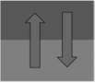

Passage area Exit or entry into plant

 Inter bay passage Crane pillar



Truss connecting two crane pillars or ladder steps

Passage Indication

Empty Area / Storage

The notation of legends doesn’t change till the end of the report. The crane pillar line as shown in fig. with crane pillar points separates one bay with another i.e., the area between two crane pillar line area denotes one bay.

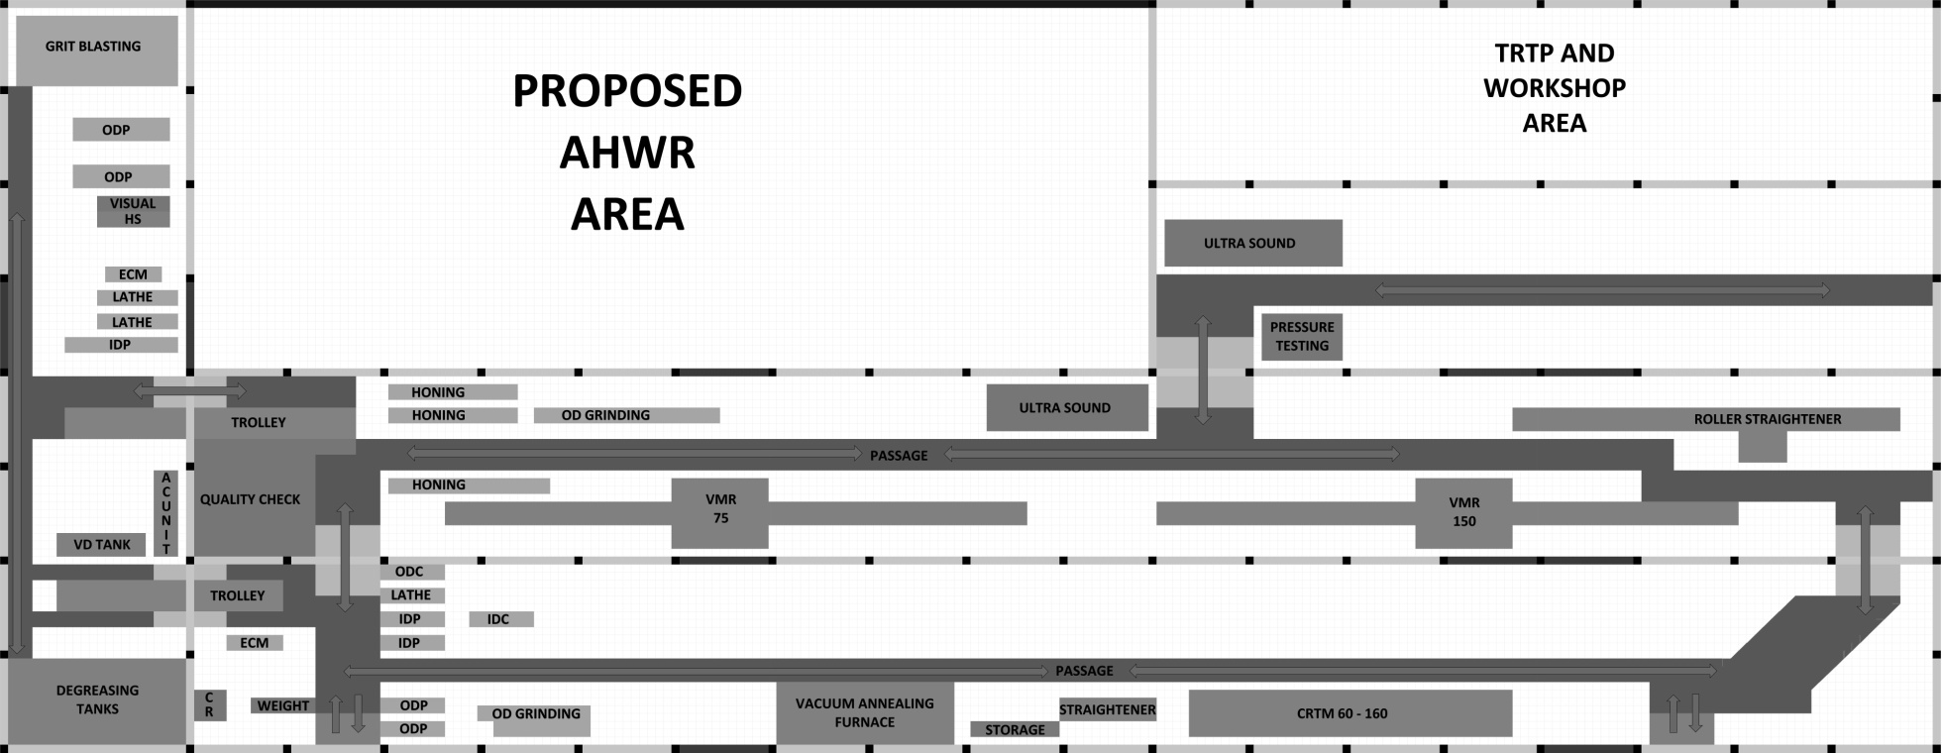

**MACHINE OPERATIONS AND INSTRUMENTS IN STP**

Only those machines and instruments which are required for the study of plant layout and mainly involved in tube manufacturing are mentioned here.

1. 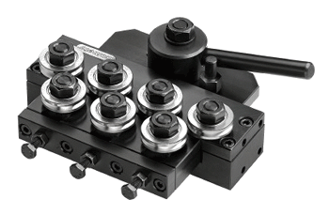**Roller straightening:** -This is used to straighten the deflected tube. It consists of hyperboloid shape like rollers which exert pressure on the tube’s deflections and deforms the tube to make it straight.(fig.2)
2. 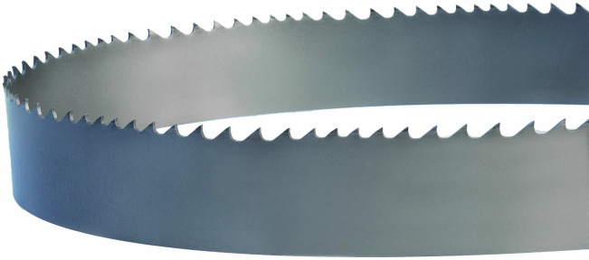**End cutting machine:** - This is a motor driven band saw type of cutting machine which is used to cut the ends of the tube.(fig.3)
3. 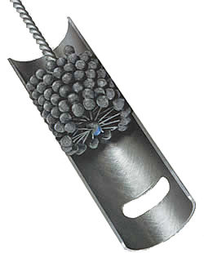**Honing:** - Machining process which increases the internal diameter of the tube by ID (Inner Diameter) surface grinding operation. The honing head is wrapped with specific grade of emery paper to carry out this process and coolant is pumped on the paper to protect the tube from overheating and avoiding the machined particles of Zirconium to catch fire by friction.(fig.4)
4. **Internal Diameter Polishing (ID Polishing):** - Similar to honing but, the machining rate compared to honing is less and smooth surface is ensured on the ID.(fig.5)

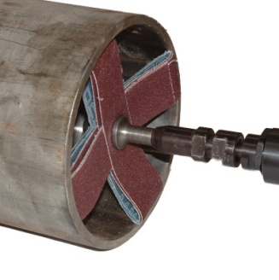

1. **Outer diameter grinding (OD grinding):** - Similar to honing but done externally on the surface of the tube. An emery paper rolls horizontally between two centers, this band is brought in contact with the tube and the grinding is carried out. Depending on the grade of emery paper, it is classified as grinding or polishing.(fig.6)
2. **Grinding wheel and pneumatic roller:** - Grinding wheel is simply a disc with grinding material vitrified to it to perform the operations of OD conditioning, which means correcting defects on the surface of the tube. The rotating disc is brought to contact on the required surface of the tube and machining is done accordingly.

Pneumatic roller contains the abrasive material like silicon carbide or alumina on its surface and it is driven by pneumatic force which rotates the roller. This is used to clear the defects on the internal surface of the tube. The roller is fixed to one of the

ends on a long tube through which compressed air is sent.

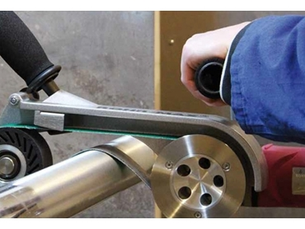

1. 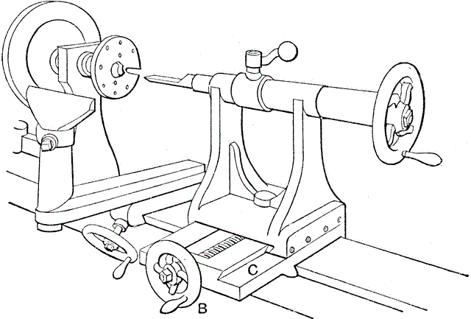**Lathe:** - There are certain end tube area operations like facing and polishing which is done on the lathe using a polishing tool.(fig.7)
2. **ID grit blasting:** - A stream of abrasive material under pressure is shot on the internal surface of the tube which brings a uniform surface removing pits and other minor defects.
3. 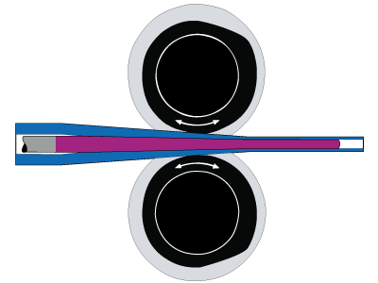**Pilgering:** - Longitudinal tube rolling process where the diameter and wall thickness of the tube is reduced simultaneously. It’s a cold working type here, to ensure the tolerance of dimensions across the tube.(fig.8)
4. **Alkali degreasing:** - When honing and pilgering of the tube is done, lot of grease and dirt is present inside and outside of the tube due to lubrication and cooling, this makes problem when the tube is fixed on other machines for machining operation so, it is given an alkali bath with a mixture of solutions like
5. **Autoclaving:** - Steam is used in this process by which, the tube is annealed and a coat of Zirconium oxide is formed on its surface to protect it from corrosion. As steam is used, the process is known as autoclaving. Takes place for nearly 48 hours.
6. **Quality check tests and equipment :-**

* **Ultrasound testing:** - Ultrasound test is based on the reflective nature of sound, when it strikes a uniform surface it strikes back again with same length but, in case of any defects like pits or non-uniformity, the length changes which is represented as a defect on a CRT screen. Probes are used here for transmitting the sound waves.(fig.9)
* **Eddy current testing:** - A coil of copper winding enclosed in a cylindrical plastic container carries current which creates magnetic flux around it. When it is inserted inside the tube which is electrically conductive and magnetically permeable, it creates

eddy currents on the internal surface of the tube, any defects like pits or scratches, the eddy current gets obstructed and the magnetic field of the copper coil changes this defect is seen on the computer screen as a variation of intensity. Used for detecting minute defects on the inner diameter of tubes.(fig.10)

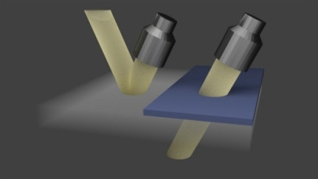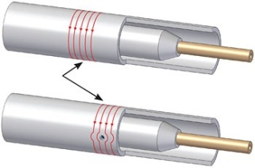

* 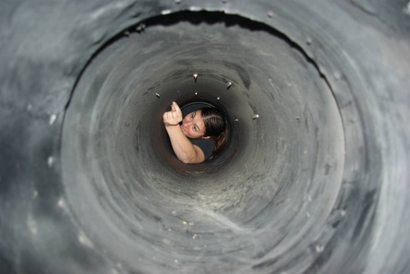**Boroscopy:** - It’s a process of examining the internal surface of the tube with the help of a concave mirror and light arrangement attached to a long stick to facilitate inward and outward motion inside the tube.(fig.11)
* **Pressure testing:** - High pressure of air is sent inside the tube to check its level of deformation i.e., if the tube is not able to withstand the pressure and any permanent deformation takes place, the tube gets rejected.

1. **High Wall Correction (HWC) and High Wall Band Correction (HBWC):** - Consider that the limits of tube wall are 25 +0.5 mm i.e., upper limit is 25.5 mm and lower limit is 25 mm if we have a tube whose variation of wall thickness is from 25.8 to 25.4 across its diameter then we have the freedom of machining the tube up to 0.3 mm across the diameter then the final dimension variation would be 25.5 mm maximum and 25.1 mm minimum which are under the limits of the wall and tube can be accepted this is known as High Wall Correction (HWC).

Again consider a tube whose variation of wall thickness is from 25.7 to 25 mm as mentioned above. Now, if we machine 0.2 mm across the diameter then the final dimension variation would be 25.5 mm maximum and 24.8 mm minimum, here, 24.8 is out of the limit and the tube cannot be accepted, to avoid this, the area of variation upto which machining under limit is possible is marked and by manually the tube is grinded on the OD grinding machine, this is known as High Wall Band Correction (HWBC).

1. **Measuring equipment:** -

* **Length of tube:** - Measuring tape.
* **Outer Diameter:** -  Pi) tape, Vernier calipers, etc.,
* **Inner Diameter:** - Bore gauge, etc.,
* **Surface roughness:** - Skid stylus.
* **Dimensional tolerances:** - Snap gauges and ovality snap gauges.
* **Bend tolerances:** - Dial test indicator and bow foot.

**MANUFACTURING OF TUBES IN STP**

There are two stages for the tube – before pilgering and after pilgering. Tube is known as blank before pilgering.

The flow diagram which will be discussed in the processes list is shown in fig.12

Sizing

Lathe operations

Weight of tube

Autoclaving

Hand Straightening

Quality Check

Dispatch

HWBC & HWC

Pressure Testing

Extrusion

Dejacketing

Roller Straightening

End Cutting

Degreasing

Annealing

ID Conditioning

Honing

Degreasing

OD Grinding

Roller Straightening

Quality Check

Ultrasound Testing

Pilgering

Degreasing

Roller Straightening

End Cutting

Honing

Degreasing

OD Polishing

Ultrasound Testing

Eddy current Testing

Grit Blasting

Boroscope

f

i

a

b

c

d

e

g

h

The coolant tube manufacturing process requires a special care because, the tubes are reactor grade and slight error in quality can cause vital changes in reactor and can interrupt the nuclear reaction which is not acceptable. The process of tube production goes as following:-

1. Extrusion Dejacketing

A layer of copper jacket is introduced on the surface of the zirconium billet to provide lubrication and resistance against oxidation which is dejacketed using pickling (nitric acid).

1. Dejacketing Roller Straightening

The extruded tube is not perfectly straight and has many deflections across its length which is undesirable for which it is straightened under low pressure and low deflection.

1. Roller Straightening End Cutting Machine

However, there is a part of ovality present at the ends of the tube, which can interfere in machining processes like honing and OD grinding for which, the ends are cut using the end cutting machine till allowable tolerance is maintained. Tube here is known as blank.

1. End Cutting Machine Degreasing

The blank contains grit and other dirt particles from extrusion and end cutting which should be removed for which, it is given a degreasing bath with alkali solution.

1. Degreasing Annealing

The residual stresses from hot work have to be relieved for facilitating pilgering of the blank for which, the tube undergoes stress relieving annealing process which makes the tube ductile and low strength is achieved.

1. Annealing ID conditioning

Crests are formed on the internal diameter of the blank due to extrusion which are grinded off by a pneumatic grinder roller head which has SiC or Alumina on its surface.

1. ID conditioning Roller Straightening

After annealing the tube has minor deflections across its length for which it has to be straightened again under high pressure.

1. Roller Straightening Honing

The machining processes on whole tube starts from here where, the tube’s ID is increased by honing which is done across the whole length of the tube, this ensures utmost uniformity of ID, coolant is also added on emery paper. The process is done for four times, changing the grade of emery paper contiguously to remove material in every pass.

1. Honing Degreasing

The coolant has to be cleaned from the tube which can be only done by an alkali degreasing bath to avoid untidiness or slipping while fixed to other machines.

1. Degreasing OD Grinding

The tube’s outer surface is also grinded off to remove the irregularities like pits, troughs, etc., similar to honing but done externally which reduces the outer diameter.

1. OD Grinding Quality Check

After all the machining processes are completed on the tube, quality checks are performed to ensure whether the tube is under standards. This includes, checking the dimensions of the tube like length, OD, ID, wall thickness, etc. If there are any defects it follows the path as shown in flow process fig.12.

1. Quality Check Ultrasound Testing

Defects at each and every point can be found by this test which is noted at the distance from the leading edge and highlighted with a marker pen at that area and follows the path as shown in flow process fig.12.

1. Ultrasound Testing Pilgering

Once there are no defects across the tube, it can go for the cold pilgering process where, the OD and wall thickness of the tube are reduced simultaneously, to the required dimensions. Pilgering of PHWR coolant tubes generally follows only one pass. The tube is no longer a blank now.

1. Pilgering Degreasing

Tube is full of lubricated oil when it comes out of pilgering so it is given an alkali degreasing bath for maintaining tidiness.

1. Degreasing Roller Straightening

The process of pilgering can create small deflections on tube for which, the tube is straightened using the roller straightener used before.

1. Roller Straightening End Cutting Machine

As seen before, both the ends possess some part of ovality which and are cut to the required length till the ovality is under allowable value by end cutting machine.

1. End Cutting Machine Honing

Again the process of machining continues for this pilgered tube, honing is done again for four times by contiguously changing the grade of emery papers so that metal is removed accordingly and required dimension is obtained.

1. Honing Degreasing

This is similar to step 9.

1. Degreasing OD polishing

The surface of the tube is already free without any scratches or irregularities which were rectified in the step 12 so, just in case of any minor scratches or defects, the tube is polished externally on the same grinding machine by changing the grade of emery paper.

1. OD polishing Ultrasound Testing

Once the tube is finished with these processes, it is sent to the Ultrasound testing in the where defects on ID & OD are more specifically shown, which are corrected as shown in the flow diagram path fig.12.

1. Ultrasound Testing Eddy current Testing

The defects on the inside surface and sub surface of tube are magnified in this test. Under defect it follows the path as shown in flow diagram fig.12.

1. Eddy current Testing Grit Blasting

Sand blasting is done to ensure uniform surface of ID from previous processes of honing.

1. Grit Blasting Boroscope

This comes under the quality check and the defects are corrected as shown in the paths of flow diagram fig.12.

1. Boroscope Sizing

Sizing refers to the dimensioning of the whole tube’s properties.

1. Sizing Pressure Testing

Certain pressure of air is pumped inside the tube where no permanent deformation of the tube should occur. If tube fails this test, it is rejected there itself.

1. Pressure Testing HWBC & HWC

These are operation are done on OD Polishing machine.

1. HWBC & HWC Lathe operations

Lathe operations include for both ends of tube which are end grinding and polishing and end facing of the tubes, done on lathe.

1. Lathe operations Weight before Autoclave

Weight of the tube has to be monitored under the limits for ensuring the reactor stability and also the consideration of weight of fuel bundles to be placed inside the tube.

1. Weight before Autoclave Autoclaving

The Autoclaving machine is two in one machine which anneals the tube from cold work of pilgering and forms the black oxide layer on the tube.

1. Autoclaving Hand Straightening

Due to annealing as mentioned previously, there are minor deflections which are corrected by a hand straightening press, which exerts low pressure to deform the tube.

1. Hand Straightening Quality Check

A final quality check ensures that the manufactured tube meets the quality requirements. The tube is dispatched after this.

Note: - Processes 1, 2 & 5 take place outside the plant.

**Chapter 4**

**4.1 Design of AHWR and implementation of study**

**4.2 Plant layout designing**

**4.3 Study of layouts**

**4.4 Designing optimised layout**

**4.5 Reasons for machines’ position**

**4.6 Choosing best layout**

**4.7 Conclusion**

**4.8 References**

**DESIGN FOR AHWR AND IMPLEMENTATION OF STUDY**

This study is implemented to the upcoming AHWR plant to design an effective route for the tube travel while manufacturing so that, less distance and time is taken as compared to the existing manufacturing route in STP according to its machine layout.

The various methods of plant’s machinery design includes:-

* **Product Layout**: - This layout follows a simple step i.e., arrange the machines according to the process of manufacturing steps of product. This is different from process layout where, the processes are separated according to their function and type like production, rework, designing, etc.

This layout is specifically dedicated to that type of product itself and no other product with different manufacturing cycle is suitable for this in terms of short traversing lengths and short time for completion.

* **Process Layout:** - Process layout is a design for the plant which aims to improve efficiency by arranging equipment according to its function.

The production line should ideally be designed to eliminate waste in material flows, inventory handling and management.

In process layout, the work stations and machinery are not arranged according to a particular production sequence. Instead, there is an assembly of similar operations or similar machinery in each department (for e.g.: metal removing department, testing department etc.)

* **Ranking method:** - Where the machines are placed according to the priority of operations like repetitiveness, importance, space, etc. This method is analogous to the mathematical ranking method. The positioning of the machines need clear input data about their prior and after machines involved in the process, its accessibility to the other plants and other necessities.

Using the above methods of plant’s machinery layout, we can make different layouts and calculate the product traversing length and time and select which layout suits the best for the plant.

All together, by examining the layouts we can then design another layout which combines the qualities of the above mentioned methods to obtain an optimum arrangement of machineries which has less product traversing length and time compared to all. This will be done by a decision making approach known as TOPSIS method which will be discussed later.

The tube manufacturing process has been discussed along with the machines and instruments in STP, by this we can create the three layouts which accordingly.

**PLANT LAYOUTS**

As discussed earlier there are three types of plant layouts which are under our area of interest, each of them will be discussed in detail and will explain about the machine arrangement.

* **Product layout: -** There are some repetitive processes in our list and for some other processes the tube has to go to other parts in the STP but, the layout is adjusted according to the cycle of manufacturing so that it moves directly from one machine to other. Doing which we obtain the layout shown in fig.13.
* **Process layout**: - In STP AHWR, Process layout is made by arranging all metal removing machines at one place, metal working machines above them and product testing machines beside them as shown in fig.14.

This arrangement provides visual control of activities and utilises space and labour efficiently and also facilitates communication and interaction between workers and supervisors.

* **Ranking method: -** Some of the processes are in need of machines which will be used from neighbouring plant. It is necessary to mind the extra distance the tube will be travelling to another plant for machining or processing.

Repeated machines will contribute more path length, and it multiplies as it repeats. If any defect or ill error is noticed, tube may have to travel through the primary machines again. Considering these machines as one system and positioning them closely is noble.

Independent machines means, which won’t repeat in the cycle and their position alteration will not display significant negative shift in the criteria like time, path length etc., the position of these machines will be fixed in the end. This is done and shown in fig.15.

Repeated machines and units include honing, OD grinding, quality check and ultrasound testing. These are included because in case of error the tube will be moving around these units repeatedly until the defect is nullified. These are also interdependent.

Independent machines are Pilgering, roller straightening, annealing and degreasing where there is no chance of inducing or finding tube’s errors.

Legends:-



Passage area Exit or entry into plant

 Inter bay passage Crane pillar



Truss connecting two crane pillars or ladder steps

Passage Indication

Empty Area / Storage

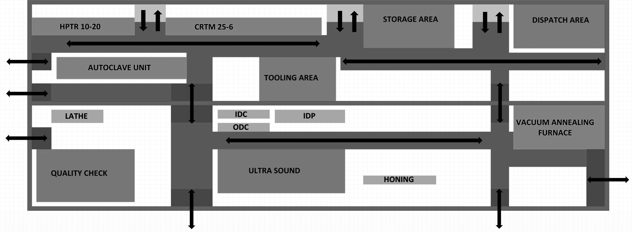

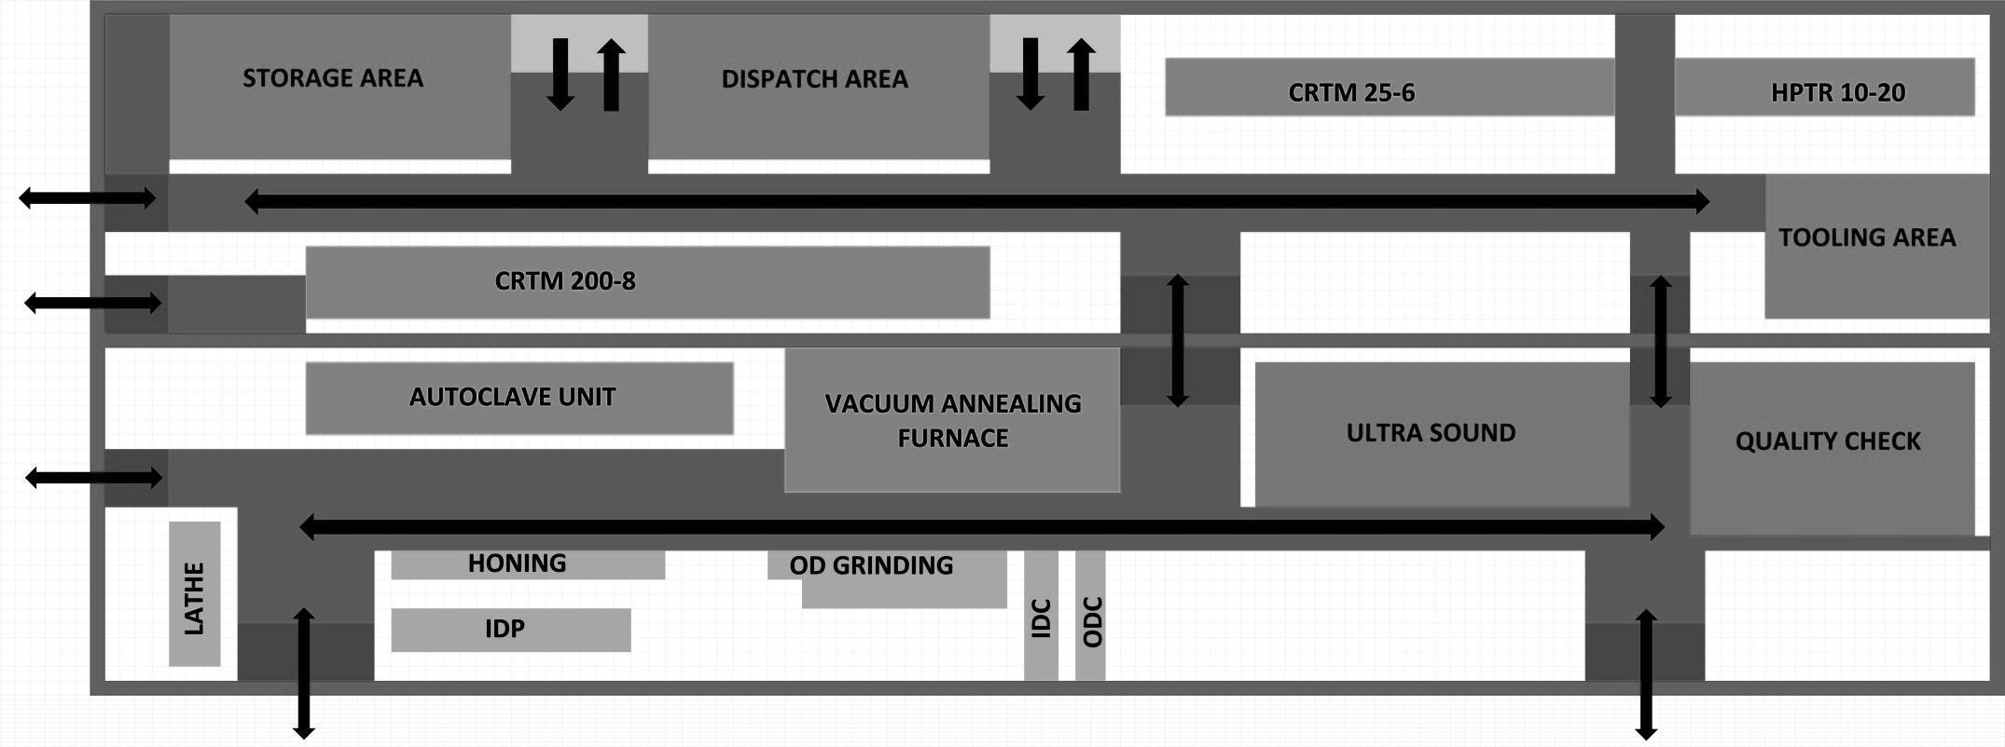

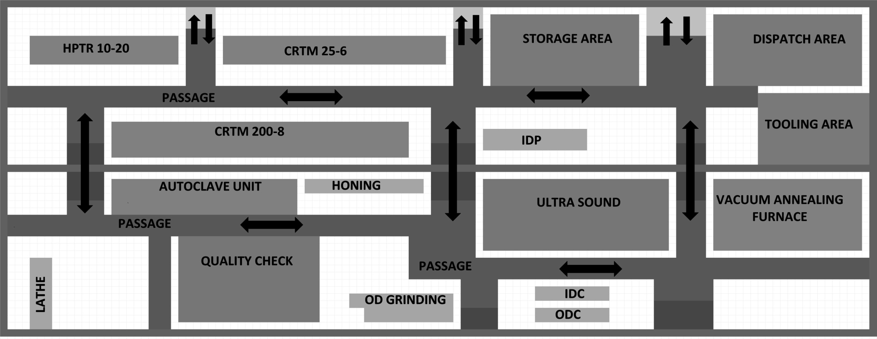

**STUDY OF LAYOUTS**

The criteria for designing the layout are many but, a few have been selected which denotes that the layout is comfortable and best suitable. Few of them are:-

* **Length: -** Denotes the maximum total distance travelled by a tube in the manufacturing process. Represented here in terms of metres.
* **Time:** - Denotes the maximum total time travelled by a tube by crane or trolley in the manufacturing process. Represented here in terms of minutes.
* **Bay transfer:** - Denotes how many times a tube was transferred from one bay to other bay by trolley in the manufacturing process. Represented here in terms of a number, also represents flexibility of workers, more the number less the flexibility.
* **Defect length:** - Denotes how much distance a tube travels in case of defect. Represented here in terms of metres.

We can now analyse each layout by these parameters and can decide which layout is the suitable one for installing. The same has been done for all layouts including the existing layout of STP and the results are as follows:-

Please refer to page no.19 for the process flow list, where it is mentioned that some processes like extrusion, dejacketing and annealing are done outside. Annealing is done in the AHWR plant itself. The table here shows only path lengths in meters of the layouts.

|  |  |  |  |  |
| --- | --- | --- | --- | --- |
| Process | STP | Product | Process | Ranking |
| Dejacketing – Roller straightening | 216+ | 216+ | 216+ | 216+ |
| Roller Straightening – End cutting | 216 | 216 | 216 | 216 |
| End cutting – Degreasing | 60 | 60 | 60 | 60 |
| Degreasing – Annealing | 72+ | 192 | 128 | 188 |
| Annealing – ID conditioning | 40+ | 100 | 24 | 60 |
| ID conditioning – Roller straightening | 220 | 208 | 168 | 160 |
| Roller Straightening – Honing | 172 | 156 | 200 | 184 |
| Honing – Degreasing | 104 | 144 | 108 | 132 |
| Degreasing – OD grinding | 120 | 124 | 136 | 136 |
| OD Grinding – Quality check | 52 | 56 | 72 | 28 |
| Quality check – Ultrasound testing | 116 | 36 | 36 | 64 |
| Ultrasound Testing – Pligering | 68 | 52 | 72 | 76 |
| Pligering – Degreasing | 232 | 152 | 168 | 132 |
| Degreasing – Roller straightening | 264 | 264 | 264 | 264 |
| Roller straightening – End cutting | 216 | 216 | 216 | 216 |
| End cutting – Honing | 56 | 112 | 68 | 100 |
| Honing – Degreasing | 104 | 144 | 68 | 132 |
| Degreasing – OD Polishing | 80 | 124 | 132 | 136 |
| OD Polishing – Ultrasound testing | 140 | 24 | 44 | 44 |
| Ultrasound testing – Eddy current testing | 116 | 36 | 28 | 64 |
| Eddy current testing – Grit blasting | 84 | 60 | 152 | 84 |
| Grit blasting – Boroscope | 84 | 60 | 152 | 84 |

|  |  |  |  |  |
| --- | --- | --- | --- | --- |
| Boroscope – Sizing | 0 | 0 | 0 | 0 |
| Sizing – Pressure testing | 152 | 144 | 52 | 120 |
| Pressure testing – HWBC & HWC | 176 | 116 | 100 | 96 |
| HWBC & HWC – Lathe operations | 20 | 32 | 52 | 56 |
| Lathe operations – Weight of tube | 36 | 0 | 0 | 0 |
| Weight of tube – Autoclaving | 56 | 20 | 36 | 40 |
| Autoclaving – Hand Straightening | 40 | 44 | 48 | 52 |
| Hand Straightening – Quality check | 52 | 28 | 120 | 52 |
| Total sum | 3364 | 3136 | 3140 | 3192 |

‘+’ sign indicates that the tube goes outside the plant and extra distance should be added accordingly. Total length traversed by tube depicts here that, the tube cannot travel more than this length in the plant. Highlighted portions indicate that the tube process is similar in STP and AHWR.

Time taken by crane to cross one crane pillar to other is about 20 seconds under load and the distance between two crane pillars is about 12 m. Here, only the time taken by the tube to travel from one machine to other is calculated as time spent on each machine is far greater than that travelled by crane. Time is represented here in minutes.

Also, bay transfer for the tubes is also calculated: -

|  |  |  |  |  |
| --- | --- | --- | --- | --- |
|  | STP | Product | Process | Ranking |
| No. of times | 19 | 18 | 21 | 21 |

Similar to the length table, the defect length of the tube in meters is calculated for all the layouts for one error cycle only. For defect number please refer to fig.12.

|  |  |  |  |  |
| --- | --- | --- | --- | --- |
| Error no. | STP | Product | Process | Ranking |
|  | 220 | 300 | 380 | 284 |
|  | 392 | 296 | 384 | 344 |
|  | 104 | 108 | 136 | 56 |
|  | 244 | 116 | 140 | 132 |
|  | 288 | 292 | 332 | 324 |
|  | 440 | 368 | 384 | 392 |
|  | 608 | 488 | 688 | 560 |
|  | 280 | 48 | 88 | 80 |
|  | 168 | 120 | 304 | 168 |
| Total | 2744 | 2136 | 2836 | 2340 |

**DESIGINING OPTIMISED LAYOUT**

**NEED:** - We have seen from the previous studies of layouts which were designed according to the rules of their guiding principles. The need for this optimised layout is that sometimes machines have to be arranged according to the will and convenience of the worker and the space limitation. Also, there can be another arbitrary arrangement followed according to comfort and not principles which can lead to better layout.

If we want to make an optimised layout, selecting the short path of machine from all layouts and arranging them will not do the job, we should be able to give a correct reason for machine position and see that it takes short distance and time.

Positioning the machines should be according to the flexibility of the workers and nearness to the workers, here is where art comes into the picture and the machine position should be given a suitable explanation. Suitable explanation is required because, for all the layouts seen before they were guided by a principle but, here there are no such principles to follow so, explanation justifies the reason of positioning.

Only major machines like CRTM, annealing furnace, autoclaving, honing, OD grinding and others have been given the reason for their position because, they have the major share of tube production process and other machines support for the production.

Machines like ID polishing, ID conditioning, OD conditioning, lathe, etc., position need not justified or given any reason because they can be shifted from one place to other or can be placed near the mother machines as support.

A suitable layout has been made shown in fig.16 for which the reasons which will be discussed in the next section and similar to the criteria discussed in the previous section for layouts are calculated here:-

|  |  |  |  |
| --- | --- | --- | --- |
| Process | Path | End cutting – Honing | 68 |
| Dejacketing – Roller straightening | 216+ | Honing – Degreasing | 92 |
| Roller Straightening – End cutting | 216 | Degreasing – OD Polishing | 112 |
| End cutting – Degreasing | 60 | OD Polishing – Ultrasound testing | 20 |
| Degreasing – Annealing | 188 | Ultrasound testing – Eddy current testing | 32 |
| Annealing – ID conditioning | 20 | Eddy current testing – Grit blasting | 60 |
| ID conditioning – Roller straightening | 136 | Grit blasting – Boroscope | 60 |
| Roller Straightening – Honing | 216 | Boroscope – Sizing | 0 |
| Honing – Degreasing | 92 | Sizing – Pressure testing | 144 |
| Degreasing – OD grinding | 112 | Pressure testing – HWBC & HWC | 124 |
| OD Grinding – Quality check | 48 | HWBC & HWC – Lathe operations | 28 |
| Quality check – Ultrasound testing | 32 | Lathe operations – Weight of tube | 0 |
| Ultrasound Testing – Pligering | 48 | Weight of tube – Autoclaving | 28 |
| Pligering – Degreasing | 144 | Autoclaving – Hand Straightening | 32 |
| Degreasing – Roller straightening | 264 | Hand Straightening – Quality check | 28 |
| Roller straightening – End cutting | 216 | Total sum | 2836 |

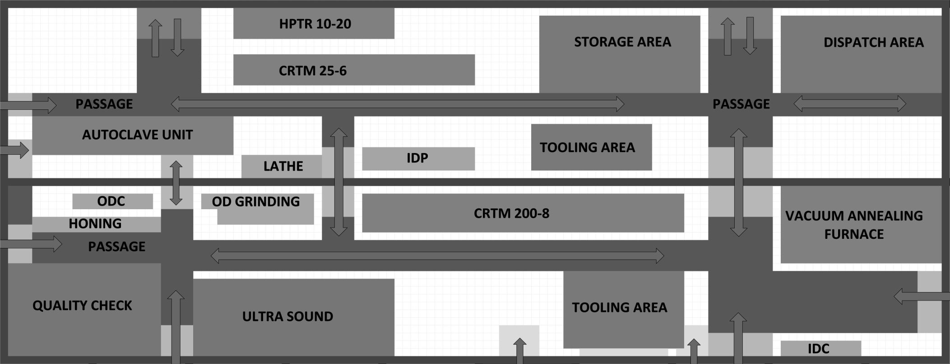

Time taken for tube travel: - 94 minutes

Bay transfer: - 21

Defect path length: -

For defect path number please refer to fig. 12.

|  |  |
| --- | --- |
| Error no. | Path length |
|  | 204 |
|  | 244 |
|  | 96 |
|  | 10 |
|  | 244 |
|  | 264 |
|  | 384 |
|  | 40 |
|  | 120 |
| Total | 1606 |

Therefore, the total data required is as follows:-

|  |  |  |  |  |  |
| --- | --- | --- | --- | --- | --- |
|  | STP | Product | Process | Ranking | Optimised |
| Length | 3364 | 3136 | 3140 | 3192 | 2836 |
| Time | 112 | 104 | 105 | 106 | 94 |
| Bay transfer | 19 | 18 | 21 | 21 | 21 |
| Defect length | 2744 | 2136 | 2836 | 2340 | 1606 |

**REASONS FOR MACHINES’ POSTION**

**HPTR & CRTM**

* Long tubes up to 30 m can be stored and dispatched easily.
* As both machines are placed close to each other, the tube can go to HPTR right after CRTM.

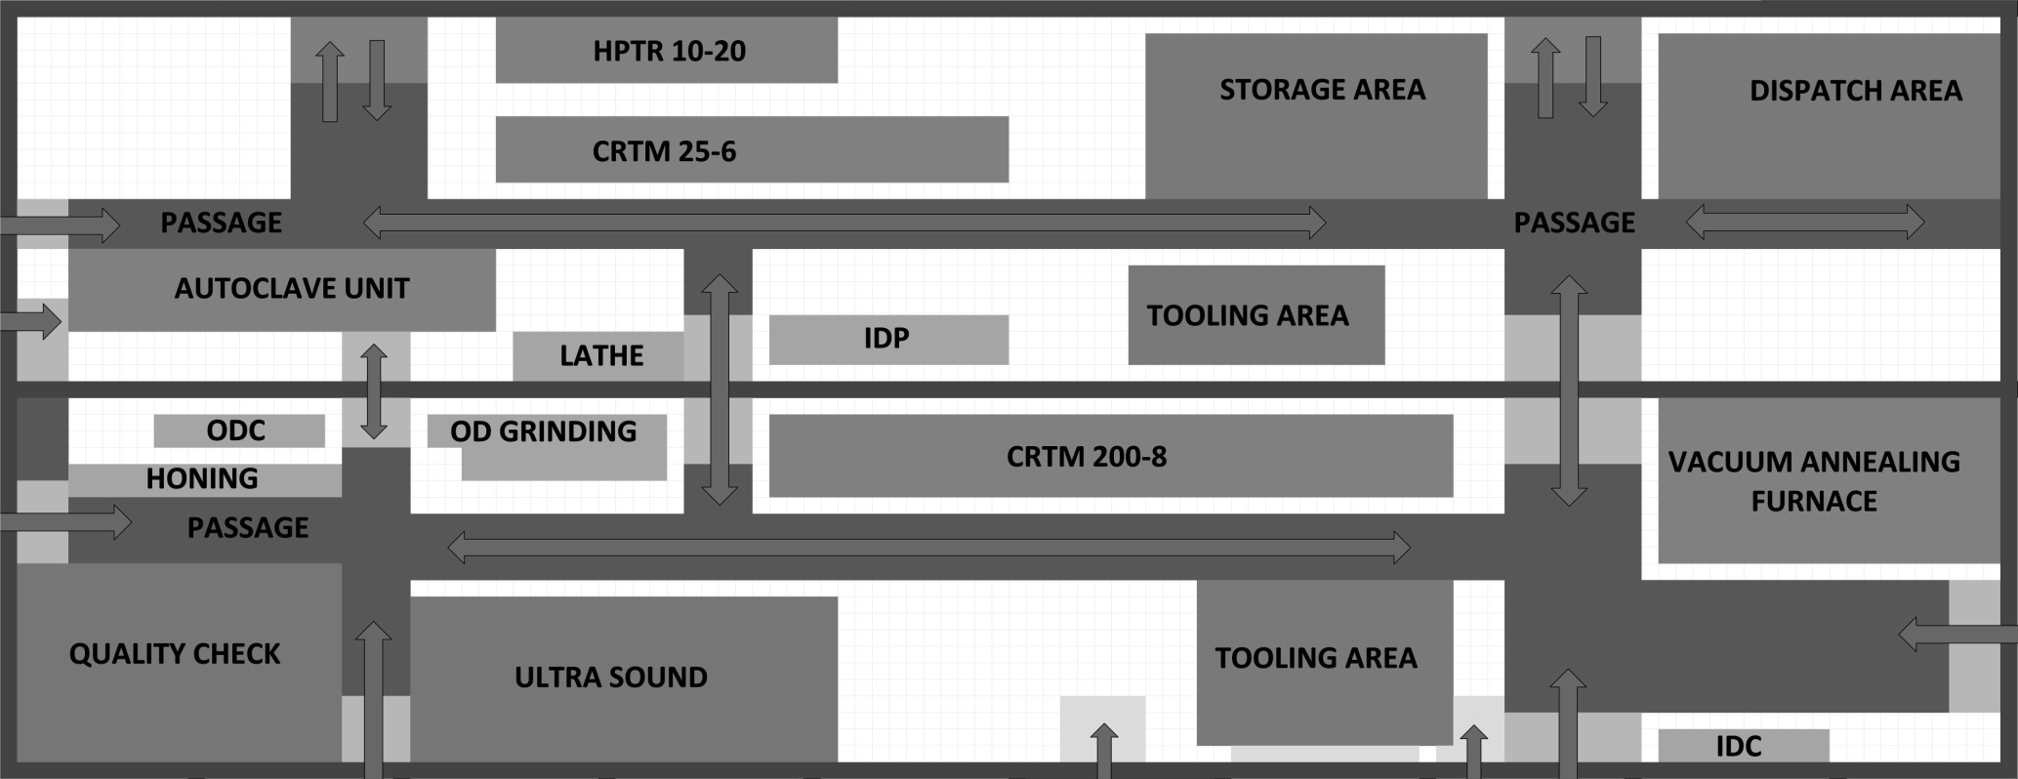

**STORAGE & DISPATCH AREA**

* Near to road which makes to dispatch and store incoming tubes easily.

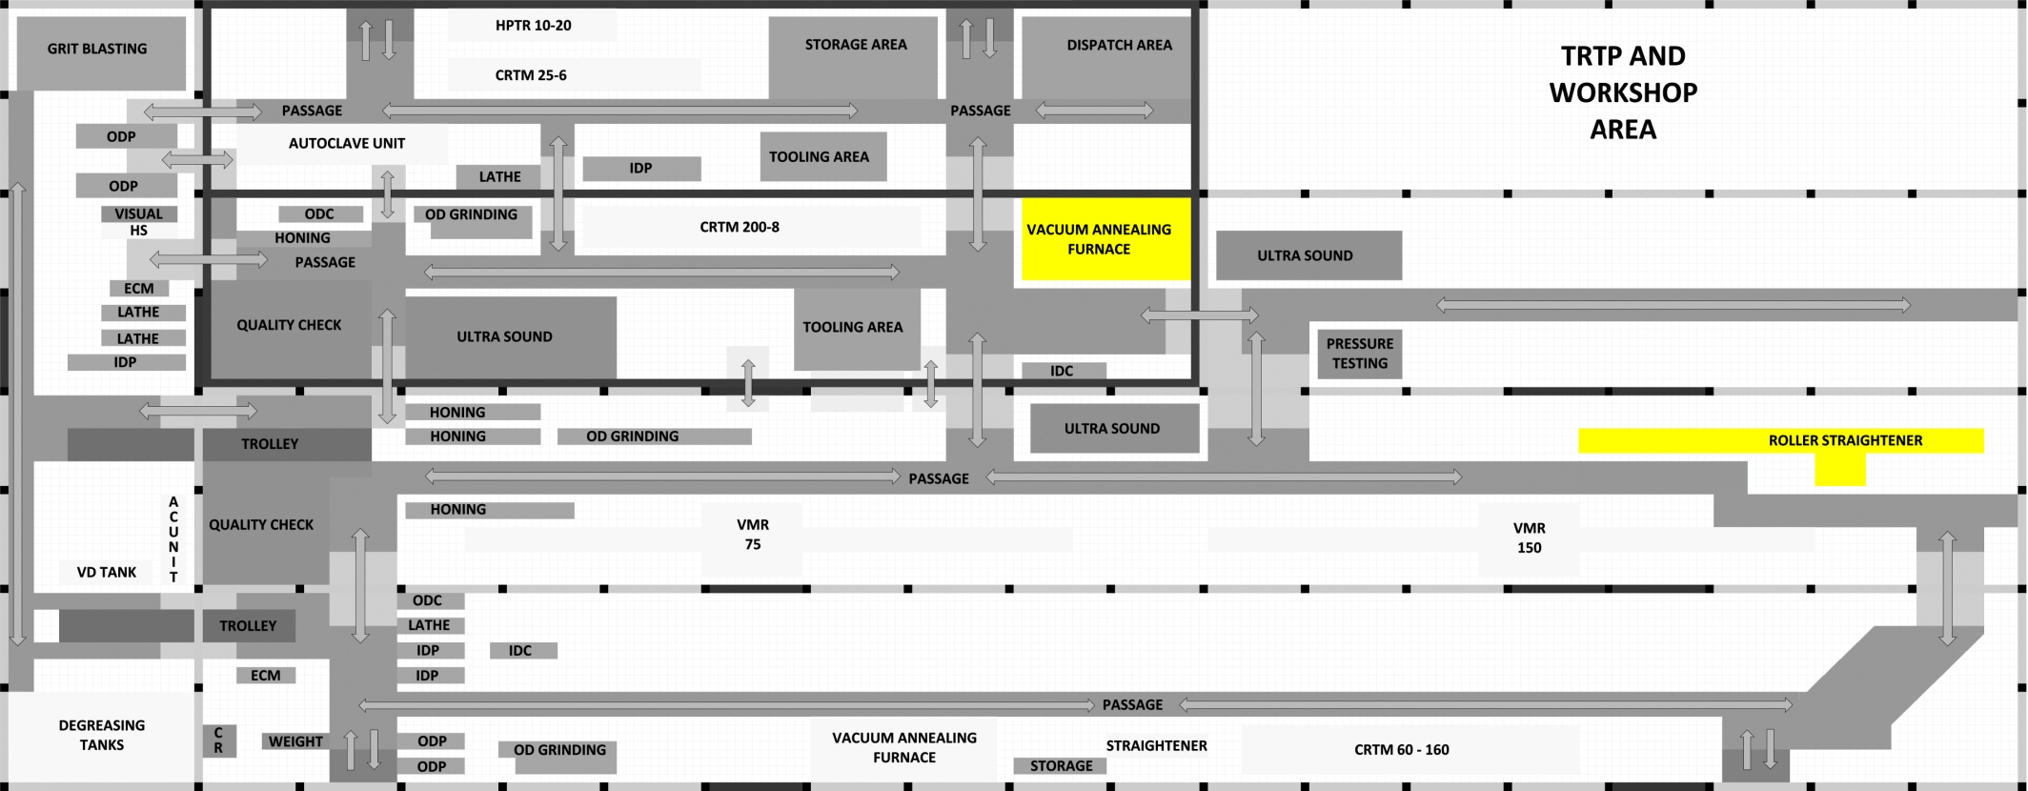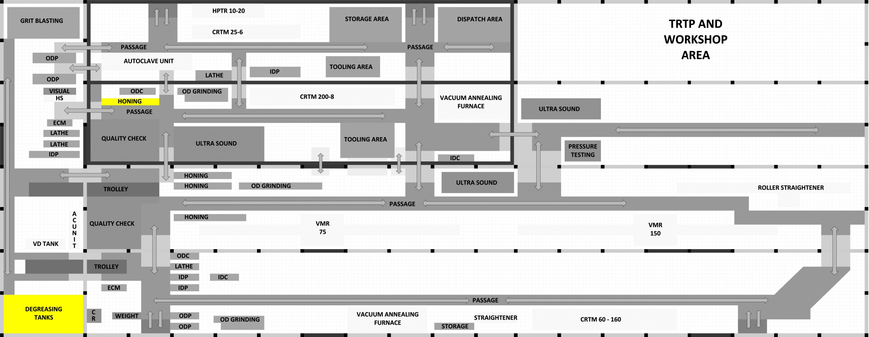

**VACUUM ANNEALING FURNACE**

* After annealing, the tube’s inner crests are machined in ID conditioning area and then it is sent for roller straightener so, furnace is placed near to it and isolated so that, while creating vacuum, noise doesn’t disturb to other workers operating at other machines.

**HONING**

* Maximum defects observed are on ID of the tube and it is corrected by honing. Even a small defect at mid position requires honing head to go to that position.
* Every time the honing is done, coolant is applied on the emery paper which sticks to the tube all along even when the defect is at mid position. This requires degreasing, whenever the tube comes to honing so, it is placed near to degreasing tanks.

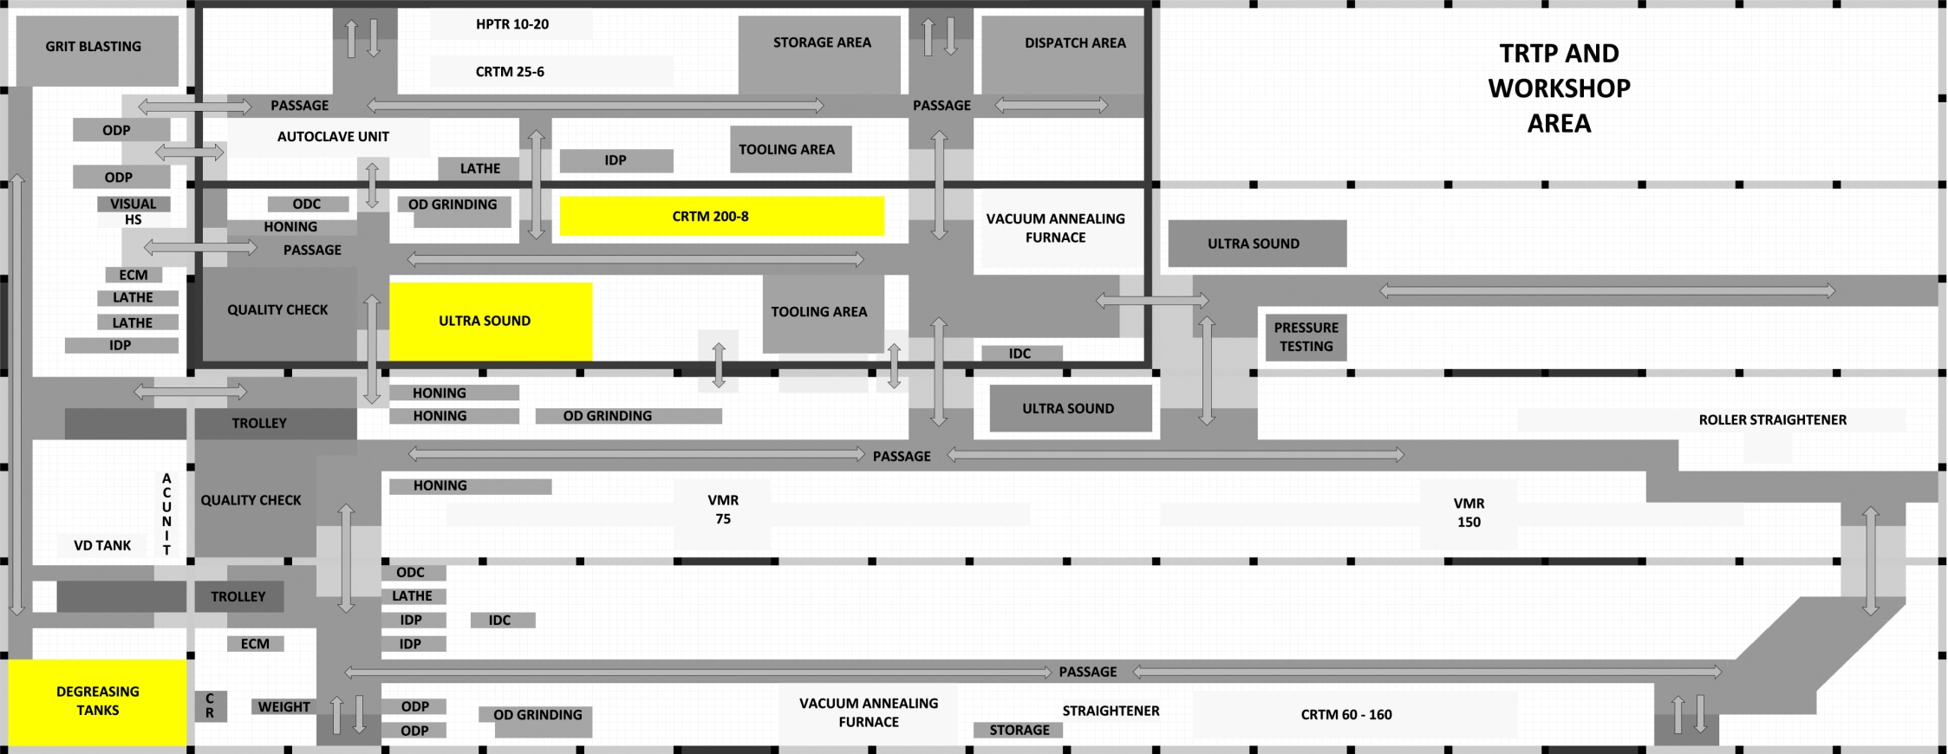

**CRTM**

* After the ultrasound test confirms that there are no defects in tube it can be sent for the pilgering process in CRTM.
* After the CRTM due to lubricant application, it has to be degreased so, it is placed near to both Ultrasound testing machine and degreasing tanks.

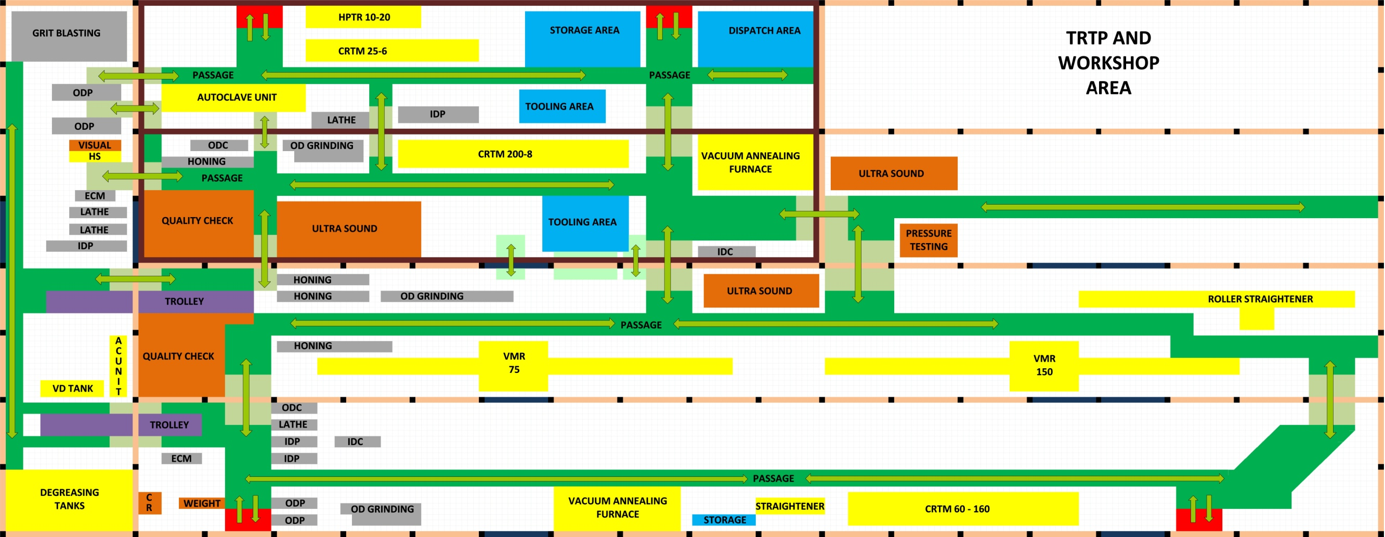

**AUTOCALVE UNIT**

* After lathe, tube directly goes autoclaving.
* After autoclaving, the hand straightening unit is very near this unit.
* The operator of autoclave unit can take charge of OD grinding as it very near.

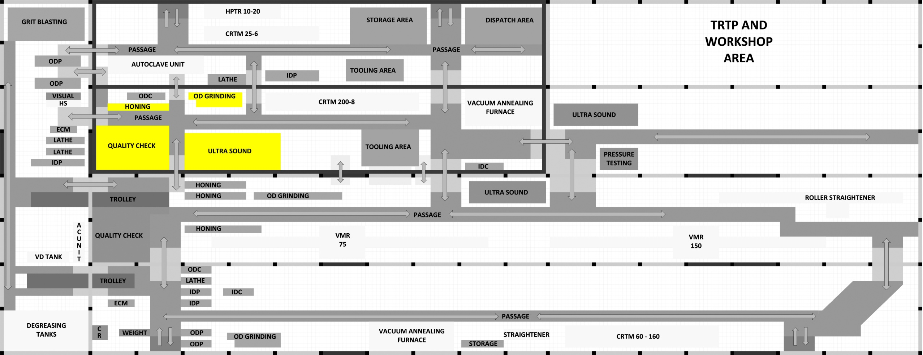

**DEFECT CORRECTING MACHINES AND DETECTING UNITS**

* The error correcting machines are honing and OD grinding, there are other machines also but, these are important.
* Quality check and Ultrasound testing detect the defects and the tube is sent to the respective machine accordingly.
* In case of repeated defects, the tube will travel less length and communication is maintained.
* The combined reason follows as mentioned to other machines before like CRTM, honing and OD grinding.

**CHOOSING THE BEST LAYOUT**

After designing our layout, we cannot say that the layout made by us the best layout as it has many criteria. To choose the best layout we have to approach for the TOPSIS method which is a multi criteria decision making method which tells us which layout is the best with a mathematical proof.

**Method of TOPSIS:** -

**T**echnique for **O**rder **P**reference by **S**imilarity to **I**deal **S**olutions (TOPSIS) was proposed by Hwang and Yoon in 1981. It is known as an ideal point multi criteria decision analysis method. The principle behind the method is that the optimal alternative should have the shortest distance from the positive ideal solution and the farthest distance from thenegative ideal solution.

The positive and negative ideal solutions are artificial alternatives which are hypothesised bythe decision-maker based on the ideal solution for all criteria and the worst solution which possesses the most inferior decision variables. Assuming every criterion has an increasing or decreasing scale, TOPSIS calculates the results by comparing distances between the actual alternatives and the hypothesised ones. For example, consider the diagram below showing 2 criteria (C1&C2) and 5 alternatives (A, B, C, D and E). Alternative C is the closest to the positive ideal solution whilst D isthe farthest from the negative ideal solution:

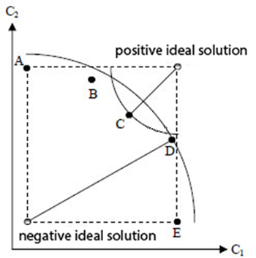

From the previous section we have made a table of criteria for the layouts which is as follows:-

|  |  |  |  |  |  |
| --- | --- | --- | --- | --- | --- |
| Criteria/layout | STP | Product | Process | Ranking | Optimised |
| Length | 3364 | 3136 | 3140 | 3192 | 2836 |
| Time | 112 | 104 | 105 | 106 | 94 |
| Bay transfer | 19 | 18 | 21 | 21 | 21 |
| Defect length | 2744 | 2136 | 2836 | 2340 | 1606 |

The first step in TOPSIS is to calculate a weighted normalized matrix using: -

Rij=

Where, Rij is the normalized value of the each criteria of each layout, hence xij, i representing the layouts and j representing the criteria. The table has been transposed and suitable weights according to priority are given here:-

|  |  |  |  |  |
| --- | --- | --- | --- | --- |
|  | Length | Time | Bay transfer | Defect Length |
| **Weight** | **0.3** | **0.2** | **0.2** | **0.3** |
| STP | 3364 | 112 | 19 | 2744 |
| Product | 3136 | 104 | 18 | 2136 |
| Process | 3140 | 105 | 21 | 2836 |
| Ranking | 3192 | 106 | 21 | 2340 |
| Optimized | 2836 | 94 | 21 | 1606 |

After the decision variables are obtained from above step, they are multiplied with the corresponding weightage of the criteria. This will add the importance of criteria factor to the ranking process. The weightage are allotted to the criteria based on the entropy weightage method i.e., weightage is assigned according to priority of criteria and the sum of all the weightages in each layout should be unity.

Weighted normalized value = weightage x normalized value.

Vij =Wj X Rij

The complete weight normalised matrix is as follows:-

|  |  |  |  |  |
| --- | --- | --- | --- | --- |
|  | Length | Time | Bay transfer | Defect Length |
| STP | 0.1438 | 0.0960 | 0.0848 | 0.1550 |
| Product | 0.1341 | 0.0891 | 0.0803 | 0.1207 |
| Process | 0.1342 | 0.0900 | 0.0937 | 0.1602 |
| Ranking | 0.1365 | 0.0908 | 0.0937 | 0.1322 |
| Optimized | 0.1212 | 0.0806 | 0.0937 | 0.0907 |

By the end of previous step we get weighted normalised decision matrix. Now we need an Ideal Positive Solution and Ideal Negative Solution. Criteria are of two types - one is positive and other is negative, the criteria’s whose values must be as big as possible to get better results are positive similarly, the criteria’s whose values must be as low as possible to get better results are negative.

In our case, all our criteria are negative type. Now, the lowest weighted normalization value (highlighted darkly) is the positive ideal solution and highest weighted normalization value (highlighted lightly) is negative ideal solution of each criteria.

Now that the positive and negative ideal solutions are known, To calculate the TOPSIS results we need to determine the separation between each alternative and the positive ideal solution / negative ideal solution.

Separation of each alternative from positive ideal solution is the square of the difference of each weighted normalized value with positive ideal solution.

Pij=(Vij – least of ( Vij ))^2

Similarly, separation of each alternative from negative ideal solution.

Nij=(Vij – highest of ( Vij ))^2

Now for each layout the positive and negative separation values are all added and are rooted to square.

Positive separation values: - (Pij)

|  |  |  |  |  |  |
| --- | --- | --- | --- | --- | --- |
|  | Length | Time | Bay transfer | Defect Length | (Pij)0.5=Aij |
| STP | 0.000509532 | 0.000237986 | 0.000019920 | 0.004134620 | 0.070014701 |
| Product | 0.000164493 | 0.000073452 | 0.000000000 | 0.000896815 | 0.033686197 |
| Process | 0.000168908 | 0.000088877 | 0.000179283 | 0.004830157 | 0.072575658 |
| Ranking | 0.000231635 | 0.000105772 | 0.000179283 | 0.001720058 | 0.047294265 |
| Optimized | 0.000000000 | 0.000000000 | 0.000179283 | 0.000000000 | 0.013389655 |

Negative separation values: - (Nij)

|  |  |  |  |  |  |
| --- | --- | --- | --- | --- | --- |
|  | Length | Time | Bay transfer | Defect Length | (Nij)0.5=Bij |
| STP | 0 | 0 | 7.9681X10-5 | 2.70226X10-5 | 0.010329756 |
| Product | 9.50109X10-5 | 4.70096X10-5 | 0.00017928 | 0.001564398 | 0.043424658 |
| Process | 9.17064X10-5 | 3.59917X10-5 | 0 | 0 | 0.011300359 |
| Ranking | 5.40705X10-5 | 2.64429X10-5 | 0 | 0.000785443 | 0.029427130 |
| Optimized | 0.000509532 | 0.000237986 | 0 | 0.004830157 | 0.074683837 |

Finally, to the results.

To calculate the TOPSIS scores for each alternative we need to divide the separation from the negative ideal solution by the sum of the positive and negative ideal solutions.

Tij=(Bij/(Aij+Bij))

|  |  |  |
| --- | --- | --- |
| 1. | STP | 0.128568367 |
| 2. | Product | 0.563145851 |
| 3. | Process | 0.134726944 |
| 4. | Ranking | 0.383558323 |
| 5. | Optimized | 0.847971792 |

|  |  |
| --- | --- |
| Rank 1 | Optimized |
| Rank 2 | Product |
| Rank 3 | Ranking |
| Rank 4 | Process |
| Rank 5 | STP |

Thus, the optimized layout is the best in terms all the selected criteria and among all the different layouts.

**CONCLUSION**

As far as possible, various layouts have been made by using different principles of plant layout and the best layout with different features favouring ease of manufacturing of tubes is selected using multi criteria mathematical technique known as TOPSIS.

All the four layouts represent different notion of flexibility and its use in different manner. It doesn’t mean that having different traversing lengths of tube directly affects the time taken in the same rate and it cannot be the only judging criteria of a layout.

**REFERENCES**

1. Mikell P Groover, “Group Technology,” in *Automation, production system and computer integrated manufacturing,* 10th ed., Prentice hall of India, New Delhi – 110001.
2. S. A. Kumar and N. Suresh, “Work study, Time and motion study,” in *Production and operations management*.
3. Srikrishna S, Sreenivasulu Reddy A and Vani S, “A new car selection in market using TOPSIS technique,” in *International Journal of Engineering Research and General Science Volume 2, Issue 4, June-July, 2014.*
4. Dr. Richard Hodgett, “Model a TOPSIS decision problem in excel,” in *Guides for Analytics, Data and Decision sciences, http://hodgett.co.uk/topsis-in-excel/*